1. **Топология с 3 шардами и фактором репликации 2**

В этой конфигурации у нас будет 3 шарда, каждый из которых реплицируется на два сервера. Всего будет использоваться 6 серверов.

<clickhouse>

<remote_servers>

<sharded_cluster>

<shard>

<internal_replication>true</internal_replication>

<replica>

<host>clickhouse4</host>

<port>9000</port>

</replica>

<replica>

<host>clickhouse5</host>

<port>9000</port>

</replica>

</shard>

<shard>

<internal_replication>true</internal_replication>

<replica>

<host>clickhouse6</host>

<port>9000</port>

</replica>

<replica>

<host>clickhouse7</host>

<port>9000</port>

</replica>

</shard>

<shard>

<internal_replication>true</internal_replication>

<replica>

<host>clickhouse8</host>

<port>9000</port>

</replica>

<replica>

<host>clickhouse9</host>

<port>9000</port>

</replica>

</shard>

</sharded_cluster>

</remote_servers>

<zookeeper>

<node index="1">

<host>zookeeper</host>

<port>2181</port>

</node>

</zookeeper>

<macros>

<cluster>sharded_cluster</cluster>

<shard>01</shard>

<replica>01</replica>

</macros>

</clickhouse>

Содержимое macros для каждого узла:

* 1. Для clickhouse4:

**<macros>**

**<cluster>sharded_cluster</cluster>**

**<shard>01</shard>**

**<replica>01</replica>**

**</macros>**

* 1. Для clickhouse5:

**<macros>**

**<cluster>sharded_cluster</cluster>**

**<shard>01</shard>**

**<replica>02</replica>**

**</macros>**

* 1. Для clickhouse6:

**<macros>**

**<cluster>sharded_cluster</cluster>**

**<shard>02</shard>**

**<replica>01</replica>**

**</macros>**

* 1. Для clickhouse7:

**<macros>**

**<cluster>sharded_cluster</cluster>**

**<shard>02</shard>**

**<replica>02</replica>**

**</macros>**

* 1. Для clickhouse8:

**<macros>**

**<cluster>sharded_cluster</cluster>**

**<shard>03</shard>**

**<replica>01</replica>**

**</macros>**

* 1. Для clickhouse9:

**<macros>**

**<cluster>sharded_cluster</cluster>**

**<shard>03</shard>**

**<replica>02</replica>**

**</macros>**

**Создание таблицы «default.trips_local» с табличным движком «ReplicatedMergeTree»**

**CREATE TABLE default.trips_local ON CLUSTER 'sharded_cluster'**

**(**

**`trip_id` UInt32,**

**`pickup_datetime` DateTime,**

**`dropoff_datetime` DateTime,**

**`pickup_longitude` Nullable(Float64),**

**`pickup_latitude` Nullable(Float64),**

**`dropoff_longitude` Nullable(Float64),**

**`dropoff_latitude` Nullable(Float64),**

**`passenger_count` UInt8,**

**`trip_distance` Float32,**

**`fare_amount` Float32,**

**`extra` Float32,**

**`tip_amount` Float32,**

**`tolls_amount` Float32,**

**`total_amount` Float32,**

**`payment_type` Enum8('CSH' = 1,**

**'CRE' = 2,**

**'NOC' = 3,**

**'DIS' = 4,**

**'UNK' = 5),**

**`pickup_ntaname` LowCardinality(String),**

**`dropoff_ntaname` LowCardinality(String)**

**)**

**ENGINE = ReplicatedMergeTree('/clickhouse/tables/{shard}/{database}/{table}', '{replica}')**

**ORDER BY (pickup_datetime, dropoff_datetime);**

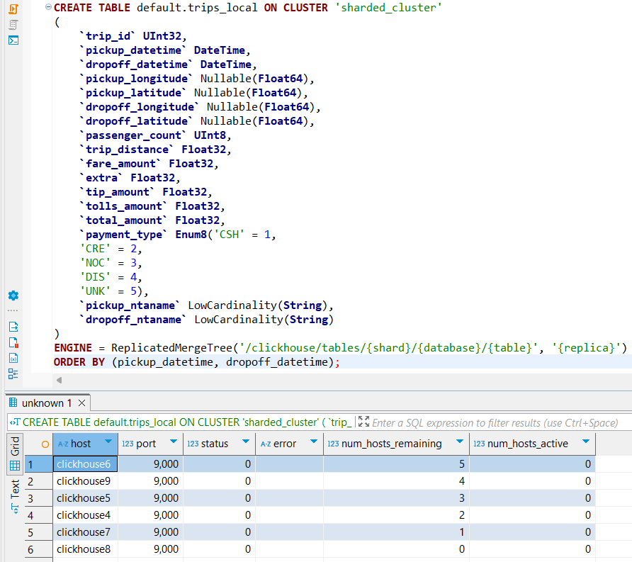

**Создание таблицы «default.trips» с табличным движком «Distributed»**

**CREATE** **TABLE** **IF** **NOT** **EXISTS** default.trips **ON** **CLUSTER** 'sharded_cluster'

(

**`trip_id`** **UInt32**,

**`pickup_datetime`** **DateTime**,

**`dropoff_datetime`** **DateTime**,

**`pickup_longitude`** Nullable(**Float64**),

**`pickup_latitude`** Nullable(**Float64**),

**`dropoff_longitude`** Nullable(**Float64**),

**`dropoff_latitude`** Nullable(**Float64**),

**`passenger_count`** **UInt8**,

**`trip_distance`** **Float32**,

**`fare_amount`** **Float32**,

**`extra`** **Float32**,

**`tip_amount`** **Float32**,

**`tolls_amount`** **Float32**,

**`total_amount`** **Float32**,

**`payment_type`** **Enum8**('CSH' = 1, 'CRE' = 2, 'NOC' = 3, 'DIS' = 4, 'UNK' = 5),

**`pickup_ntaname`** LowCardinality(**String**),

**`dropoff_ntaname`** LowCardinality(**String**)

)

**ENGINE** = Distributed('sharded_cluster', 'default', 'trips_local', rand());

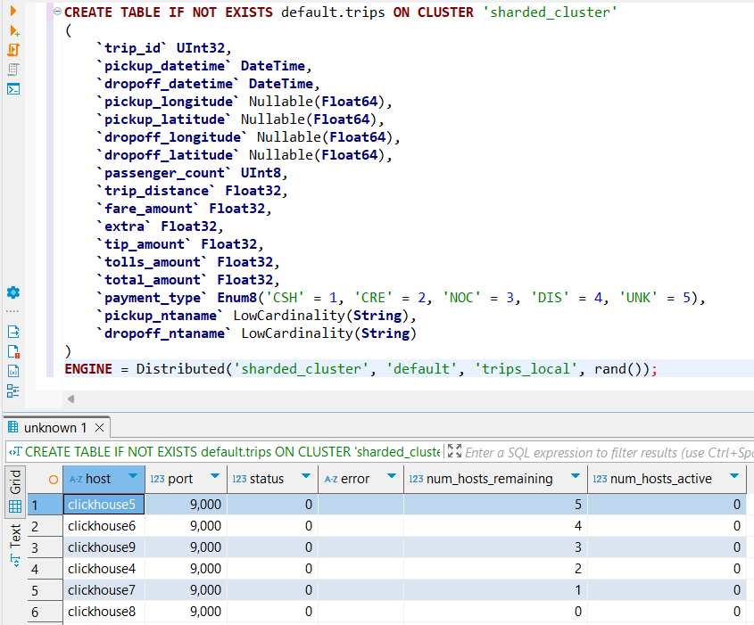

Вставка данных в таблицу «default.trips»

**INSERT** **INTO** default.trips

**SELECT**

trip_id,

pickup_datetime,

dropoff_datetime,

pickup_longitude,

pickup_latitude,

dropoff_longitude,

dropoff_latitude,

passenger_count,

trip_distance,

fare_amount,

extra,

tip_amount,

tolls_amount,

total_amount,

payment_type,

pickup_ntaname,

dropoff_ntaname

**FROM**

gcs('https://storage.googleapis.com/clickhouse-public-datasets/nyc-taxi/trips_{0..2}.gz',

'TabSeparatedWithNames'

);

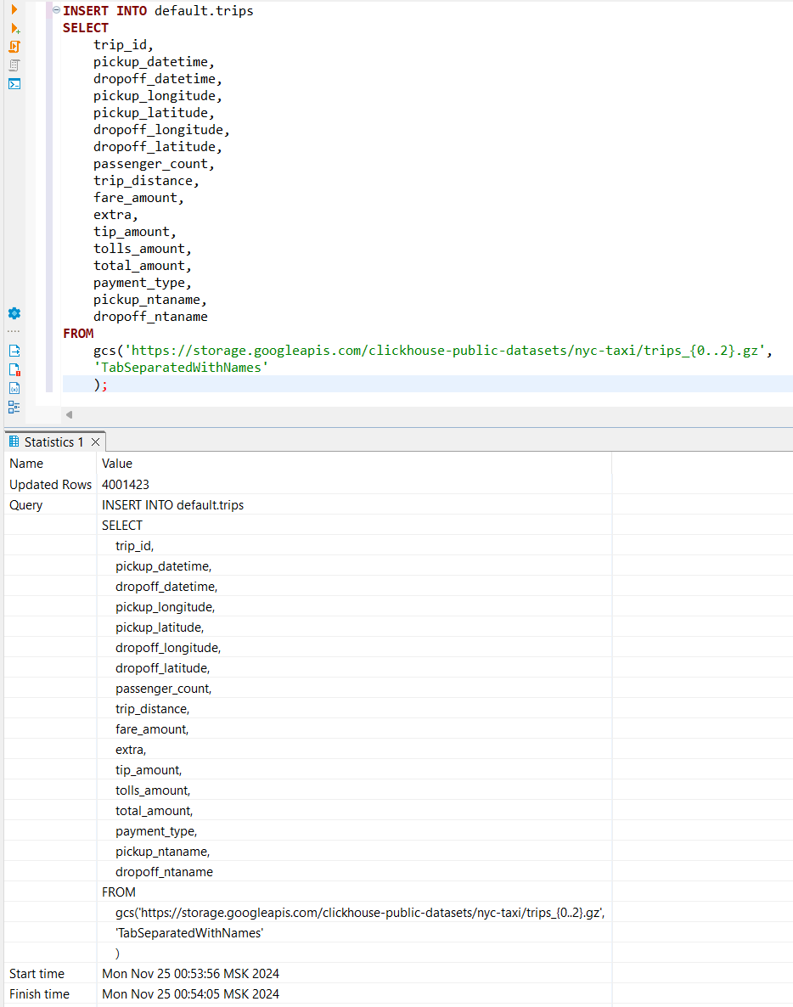

Проверка выполнения

**SELECT** * **FROM** system.clusters;

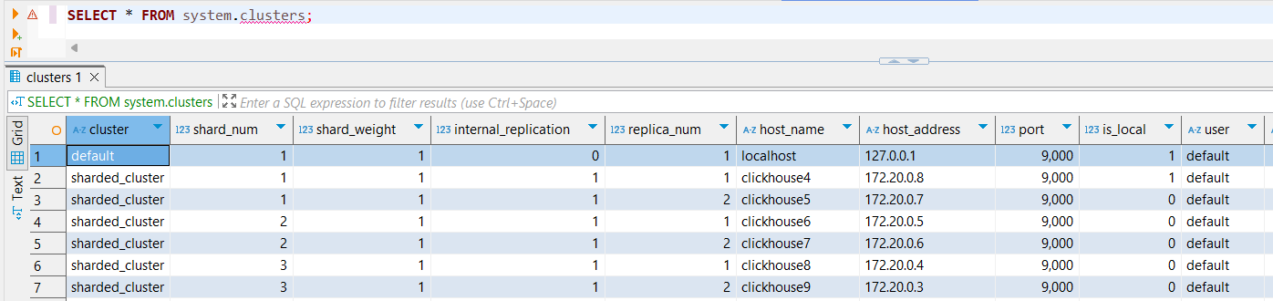

**SHOW** **CREATE** **TABLE** default.trips

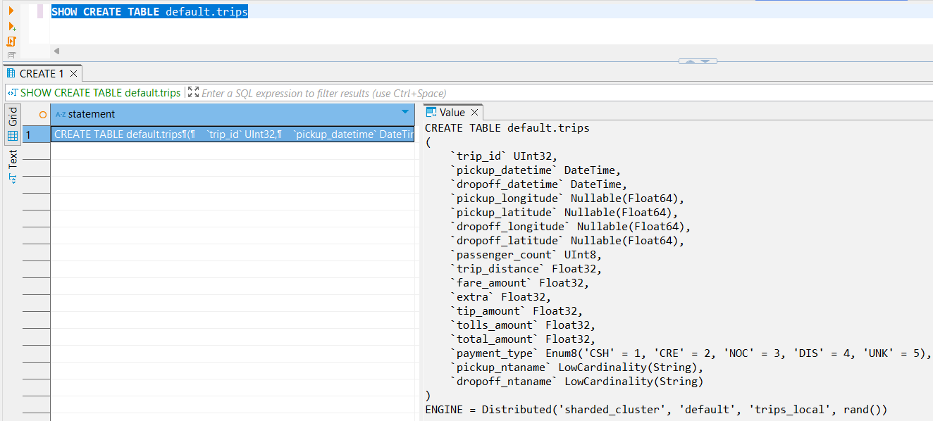

1. **Топология с 4 шардами и фактором репликации 3**

В этой конфигурации у нас будет 4 шарда, каждый из которых реплицируется на три сервера. Всего будет использоваться 12 серверов.

<clickhouse>

<remote_servers>

<sharded_cluster_sh4r3>

<shard>

<internal_replication>true</internal_replication>

<replica>

<host>clickhouse10</host>

<port>9000</port>

</replica>

<replica>

<host>clickhouse11</host>

<port>9000</port>

</replica>

<replica>

<host>clickhouse12</host>

<port>9000</port>

</replica>

</shard>

<shard>

<internal_replication>true</internal_replication>

<replica>

<host>clickhouse13</host>

<port>9000</port>

</replica>

<replica>

<host>clickhouse14</host>

<port>9000</port>

</replica>

<replica>

<host>clickhouse15</host>

<port>9000</port>

</replica>

</shard>

<shard>

<internal_replication>true</internal_replication>

<replica>

<host>clickhouse16</host>

<port>9000</port>

</replica>

<replica>

<host>clickhouse17</host>

<port>9000</port>

</replica>

<replica>

<host>clickhouse18</host>

<port>9000</port>

</replica>

</shard>

<shard>

<internal_replication>true</internal_replication>

<replica>

<host>clickhouse19</host>

<port>9000</port>

</replica>

<replica>

<host>clickhouse20</host>

<port>9000</port>

</replica>

<replica>

<host>clickhouse21</host>

<port>9000</port>

</replica>

</shard>

</sharded_cluster_sh4r3>

</remote_servers>

<zookeeper>

<node index="1">

<host>zookeeper</host>

<port>2181</port>

</node>

</zookeeper>

<macros>

<cluster>sharded_cluster_sh4r3</cluster>

<shard>01</shard>

<replica>01</replica>

</macros>

</clickhouse>

Содержимое macros для каждого узла:

* 1. Для clickhouse10:

**<macros>**

**<cluster>sharded_cluster</cluster>**

**<shard>01</shard>**

**<replica>01</replica>**

**</macros>**

* 1. Для clickhouse11:

**<macros>**

**<cluster>sharded_cluster</cluster>**

**<shard>01</shard>**

**<replica>02</replica>**

**</macros>**

* 1. Для clickhouse12:

**<macros>**

**<cluster>sharded_cluster</cluster>**

**<shard>01</shard>**

**<replica>03</replica>**

**</macros>**

* 1. Для clickhouse13:

**<macros>**

**<cluster>sharded_cluster</cluster>**

**<shard>02</shard>**

**<replica>01</replica>**

**</macros>**

* 1. Для clickhouse14:

**<macros>**

**<cluster>sharded_cluster</cluster>**

**<shard>02</shard>**

**<replica>02</replica>**

**</macros>**

* 1. Для clickhouse15:

**<macros>**

**<cluster>sharded_cluster</cluster>**

**<shard>02</shard>**

**<replica>03</replica>**

**</macros>**

* 1. Для clickhouse16:

**<macros>**

**<cluster>sharded_cluster</cluster>**

**<shard>03</shard>**

**<replica>01</replica>**

**</macros>**

* 1. Для clickhouse17:

**<macros>**

**<cluster>sharded_cluster</cluster>**

**<shard>03</shard>**

**<replica>02</replica>**

**</macros>**

* 1. Для clickhouse18:

**<macros>**

**<cluster>sharded_cluster</cluster>**

**<shard>03</shard>**

**<replica>03</replica>**

**</macros>**

**Создание таблицы «default.trips_local» с табличным движком «ReplicatedMergeTree»**

**CREATE TABLE default.trips_local ON CLUSTER 'sharded_cluster'**

**(**

**`trip_id` UInt32,**

**`pickup_datetime` DateTime,**

**`dropoff_datetime` DateTime,**

**`pickup_longitude` Nullable(Float64),**

**`pickup_latitude` Nullable(Float64),**

**`dropoff_longitude` Nullable(Float64),**

**`dropoff_latitude` Nullable(Float64),**

**`passenger_count` UInt8,**

**`trip_distance` Float32,**

**`fare_amount` Float32,**

**`extra` Float32,**

**`tip_amount` Float32,**

**`tolls_amount` Float32,**

**`total_amount` Float32,**

**`payment_type` Enum8('CSH' = 1,**

**'CRE' = 2,**

**'NOC' = 3,**

**'DIS' = 4,**

**'UNK' = 5),**

**`pickup_ntaname` LowCardinality(String),**

**`dropoff_ntaname` LowCardinality(String)**

**)**

**ENGINE = ReplicatedMergeTree('/clickhouse/tables/{shard}/{database}/{table}', '{replica}')**

**ORDER BY (pickup_datetime, dropoff_datetime);**

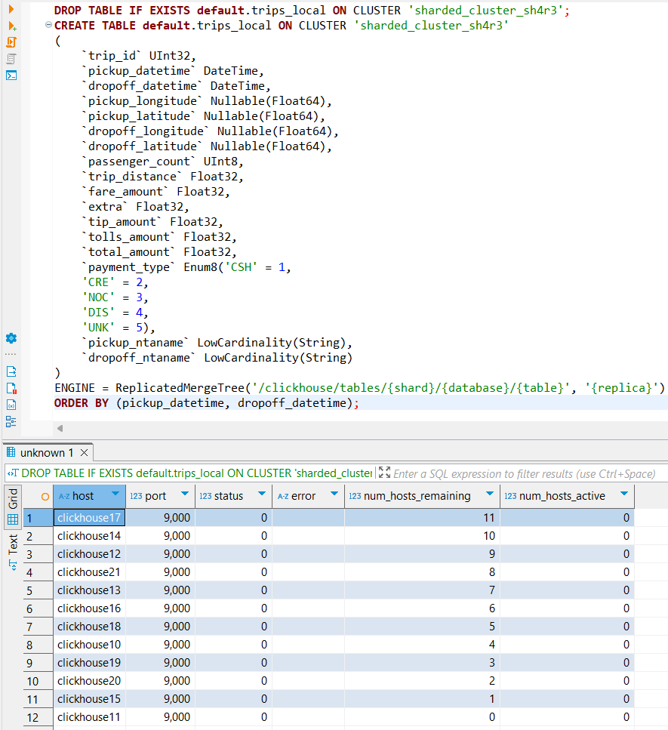

**Создание таблицы «default.trips» с табличным движком «Distributed»**

**DROP TABLE IF EXISTS default.trips ON CLUSTER 'sharded_cluster_sh4r3';**

**CREATE TABLE IF NOT EXISTS default.trips ON CLUSTER 'sharded_cluster_sh4r3'**

**(**

**`trip_id` UInt32,**

**`pickup_datetime` DateTime,**

**`dropoff_datetime` DateTime,**

**`pickup_longitude` Nullable(Float64),**

**`pickup_latitude` Nullable(Float64),**

**`dropoff_longitude` Nullable(Float64),**

**`dropoff_latitude` Nullable(Float64),**

**`passenger_count` UInt8,**

**`trip_distance` Float32,**

**`fare_amount` Float32,**

**`extra` Float32,**

**`tip_amount` Float32,**

**`tolls_amount` Float32,**

**`total_amount` Float32,**

**`payment_type` Enum8('CSH' = 1, 'CRE' = 2, 'NOC' = 3, 'DIS' = 4, 'UNK' = 5),**

**`pickup_ntaname` LowCardinality(String),**

**`dropoff_ntaname` LowCardinality(String)**

**)**

**ENGINE = Distributed('sharded_cluster_sh4r3', 'default', 'trips_local', rand());**

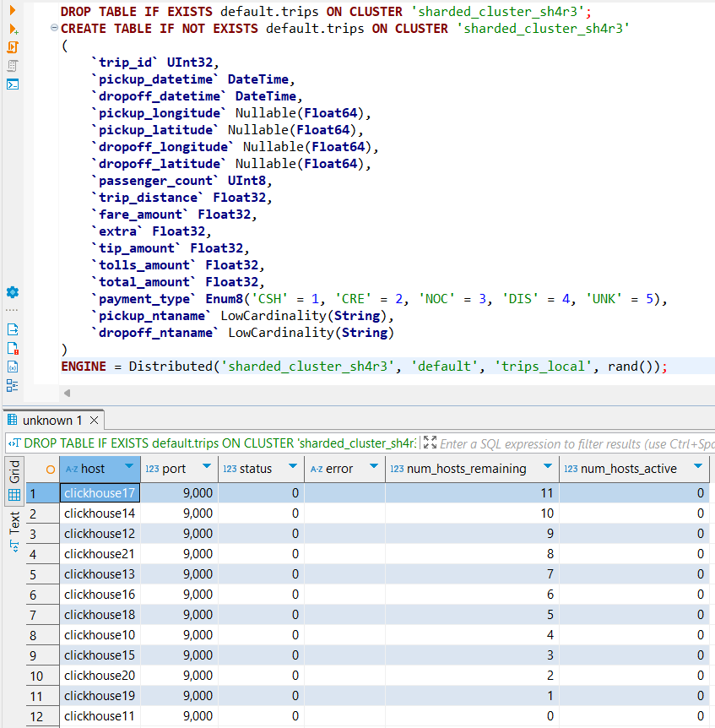

Вставка данных в таблицу «default.trips»

**INSERT** **INTO** default.trips

**SELECT**

trip_id,

pickup_datetime,

dropoff_datetime,

pickup_longitude,

pickup_latitude,

dropoff_longitude,

dropoff_latitude,

passenger_count,

trip_distance,

fare_amount,

extra,

tip_amount,

tolls_amount,

total_amount,

payment_type,

pickup_ntaname,

dropoff_ntaname

**FROM**

gcs('https://storage.googleapis.com/clickhouse-public-datasets/nyc-taxi/trips_{0..2}.gz',

'TabSeparatedWithNames'

);

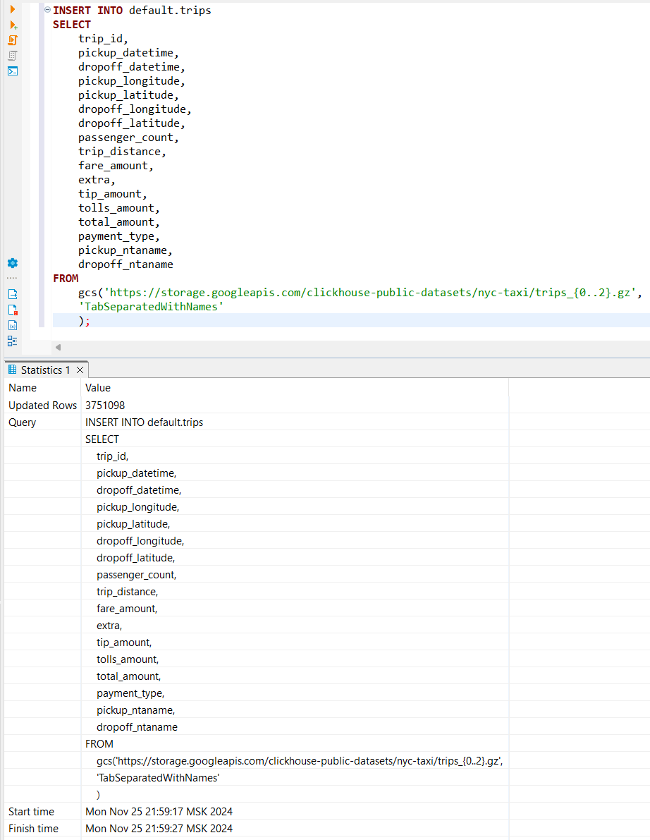

Проверка выполнения

**SELECT** * **FROM** system.clusters;

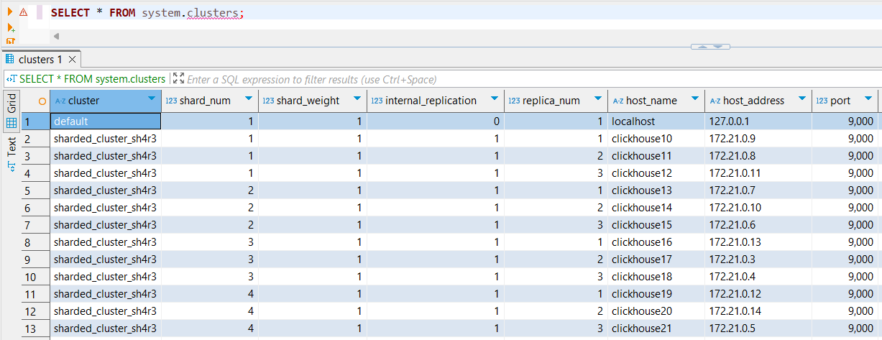

**SHOW** **CREATE** **TABLE** default.trips

